**Nama : Qirani Rifa Annisa  
NIM : 18090057  
Kelas : 5D**

1. **Source Code**Web.php -> application/controllersv_header.php -> application/viewsv_index.php -> application/viewsv_footer.php -> application/viewsv_bootstrap.php -> application/viewsstylebook.css -> assets/css
2. **URL**<http://localhost/Pustaka_Qirani5D/web>  
   [http://localhost/Pustaka_Qirani5D /web/about](http://localhost/Pustaka_Qirani5D%20/web/about)
3. **Capture Hasil**

**web**

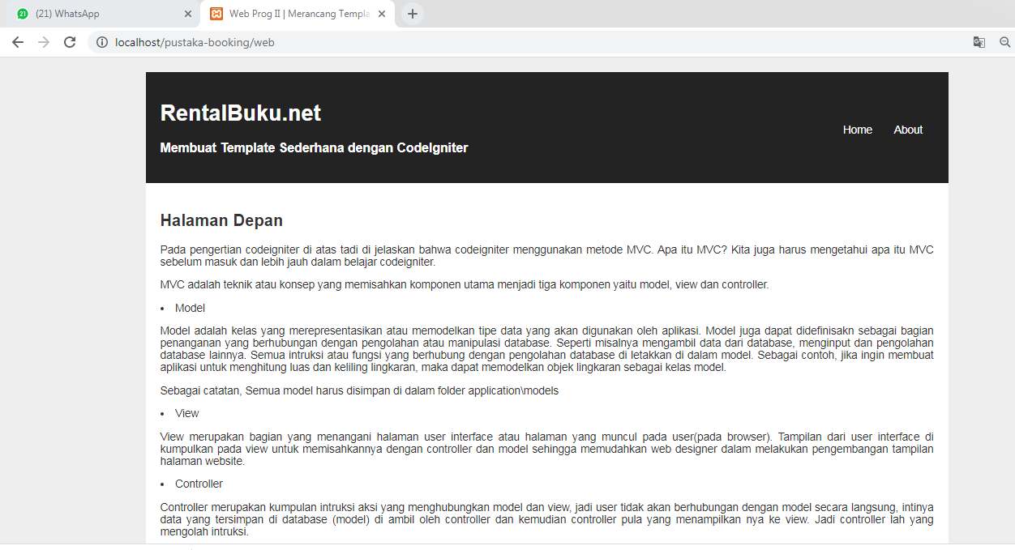

**web/about**

